Insert your centre number, name and candidate number into the header above.
Save this evidence document as evidence_ followed by your centre number_ candidate number. For example: evidence_ zz999_9999
Screenshots or program listings must be copied into appropriate cells in the following table.
Examiners must be able to read the contents including any screenshots without the use of a magnifying glass. Answers that are not readable or missing will not be awarded any marks.
Save this evidence document at regular intervals, for example every 10 minutes.
Question 1
Part 1(a)
StackData = []
StackPointer = 0
MAX_SIZE = 10

Part 1(b)
def OutputStack() -> None:
global StackData, StackPointer
print(StackPointer)
for data in StackData:
print(data)

Part 1(c)
def Push(value: int) -> bool:
global StackData, StackPointer
# print("StackPointer", StackPointer, StackPointer >= MAX_SIZE)
if StackPointer >= MAX_SIZE:
# ("Stack is full!")
return False
else:
# print("StackPointer else", StackPointer)
StackPointer += 1
StackData.append(value)
return True

Part 1(d)(i)
for i in range(11):
while True:
inp = input(f"Enter integer {i + 1}: ").strip()
try:
if "." in inp:
raise ValueError
inp = int(inp)
break
except ValueError:
print("Please enter a valid integer")

res = Push(value=inp)
if not res:
print("Stack is full!")
break
else:
print(f"Stored {inp}")

OutputStack()

Part 1(d)(ii)
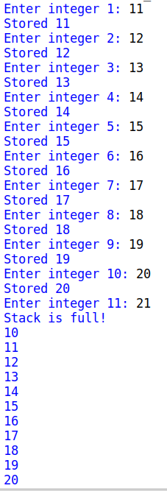

Part 1(e)(i)
def Pop() -> int:
global StackData, StackPointer
if StackPointer == 0:
print("Stack is empty!")
return -1
else:
StackPointer -= 1
return StackData.pop()

Part 1(e)(ii)
Pop()
Pop()
OutputStack()

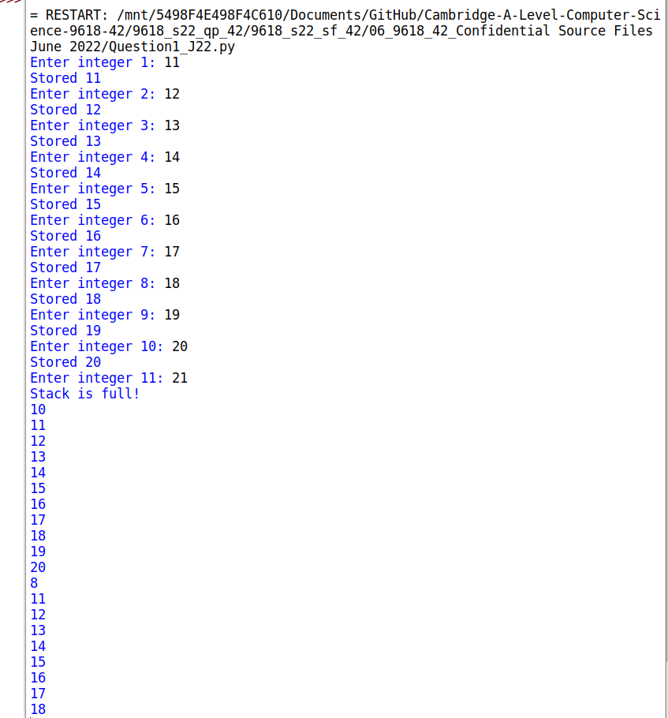

Question 2
Part 2(a)
{Copy and paste the program code listing for Question 2(a) here}

Part 2(b)(i)
{Copy and paste the program code listing for Question 2(b)(i) here}

Part 2(b)(ii)
{Copy and paste the program code listing for Question 2(b)(ii) here}

Part 2(b)(iii)
{Copy and paste the screenshot for Question 2(b)(iii) here}

Part 2(c)(i)
{Copy and paste the program code listing for Question 2(c)(i) here}

Part 2(c)(ii)
{Copy and paste the screenshot for Question 2(c)(ii) here}

Question 3
Part 3(a)
{Copy and paste the program code listing for Question 3(a) here}

Part 3(b)
{Copy and paste the program code listing for Question 3(b) here}

Part 3(c)
{Copy and paste the program code listing for Question 3(c) here}

Part 3(d)
{Copy and paste the program code listing for Question 3(d) here}

Part 3(e)(i)
{Copy and paste the program code listing for Question 3(e)(i) here}

Part 3(e)(ii)
{Copy and paste the screenshot for Question 3(e)(ii) here}

